1. **INTRODUCTION**
   1. *overview*
      * *Description of the project*

Project Description:

Bright Ideas Consulting, a consulting firm, relies on Zoho Books to track their billable hours, expenses, and client invoices. The software helps them accurately calculate project costs, monitor profitability, and generate reports for better financial management. Bright Ideas Consulting is a Private Limited company also registered under GST in Tamil Nadu. Bright Ideas Consulting offers various expert consulting services in India and outside India.

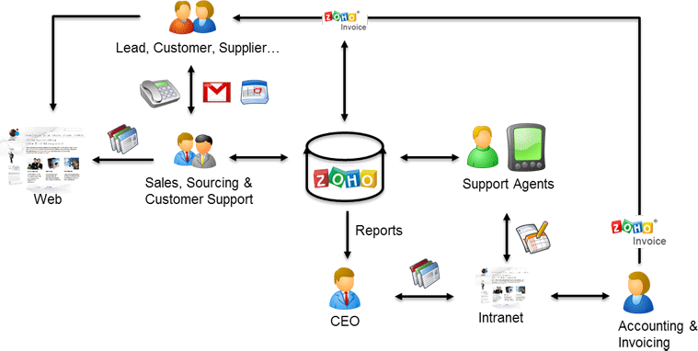

1. **Problem definition & design Thinking**
   1. *Empathy map*
   2. *Empathy map*

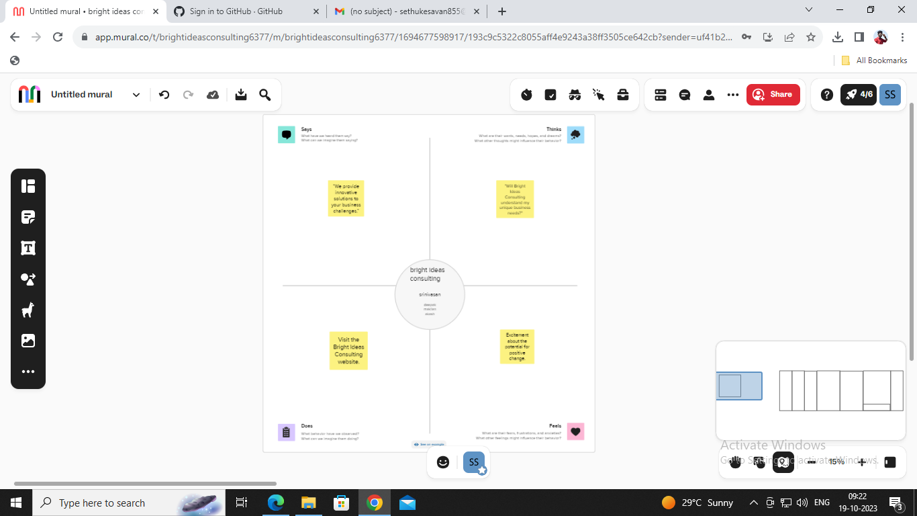

*Ideation & Brainstorming map*

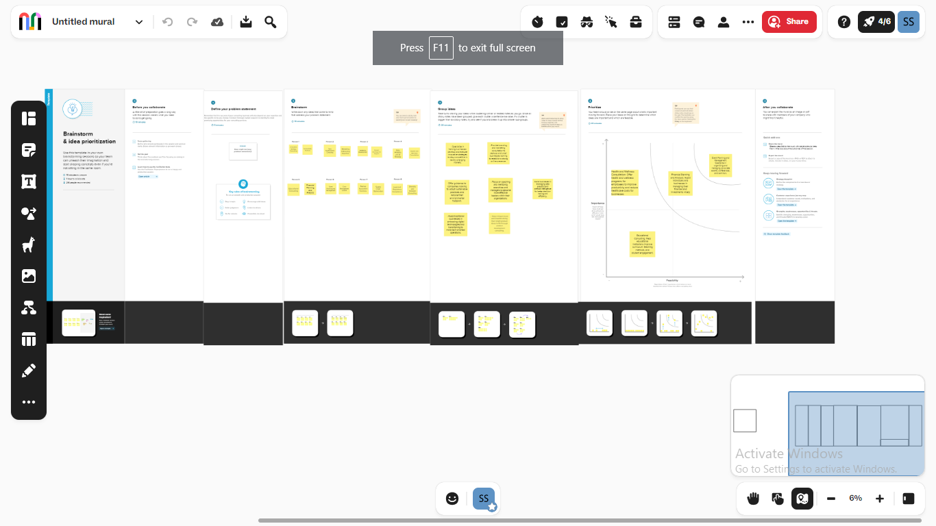

1. **Result Profit&loss**

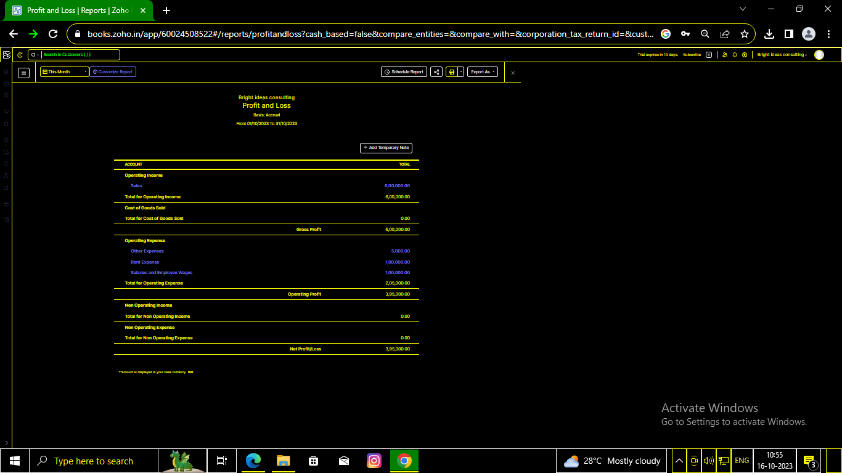

Balance sheet:

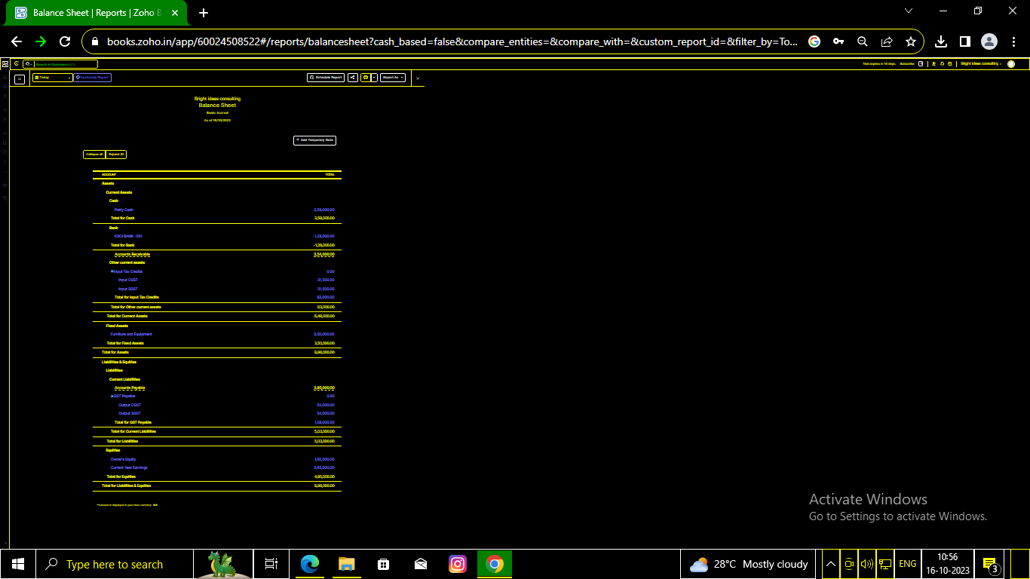

Purchase order:

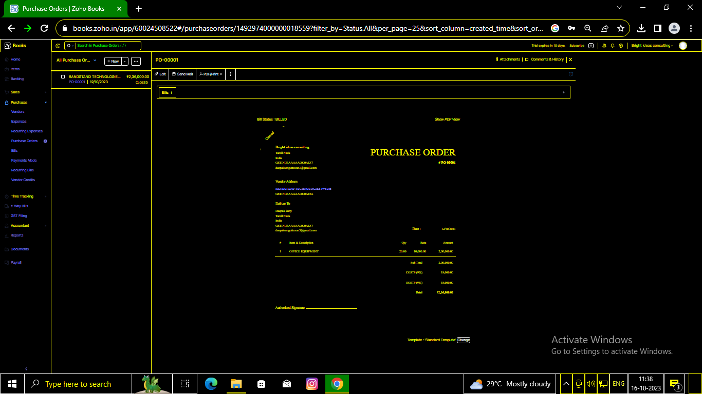

Sales order:

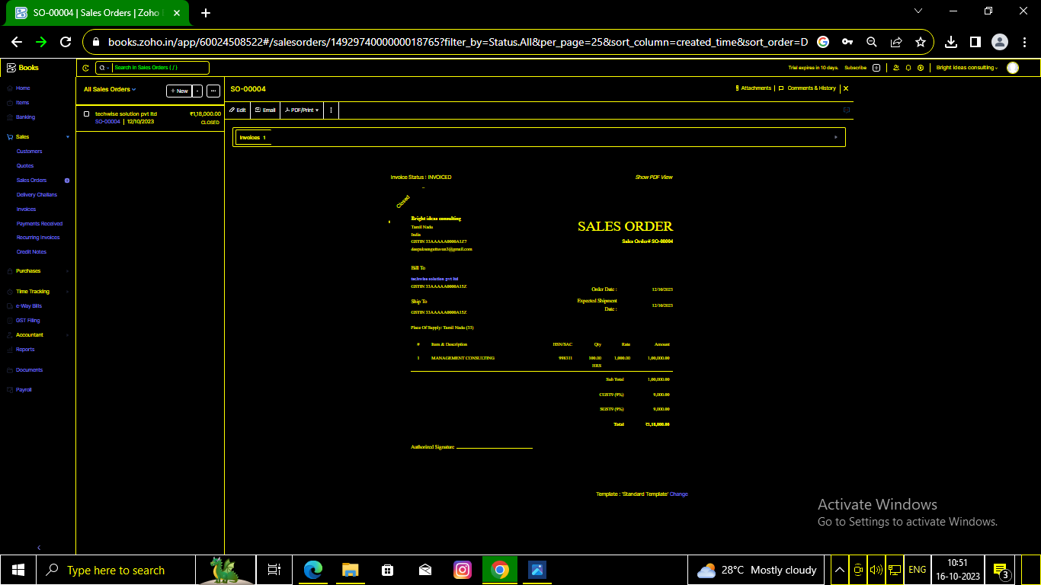

Invoices :

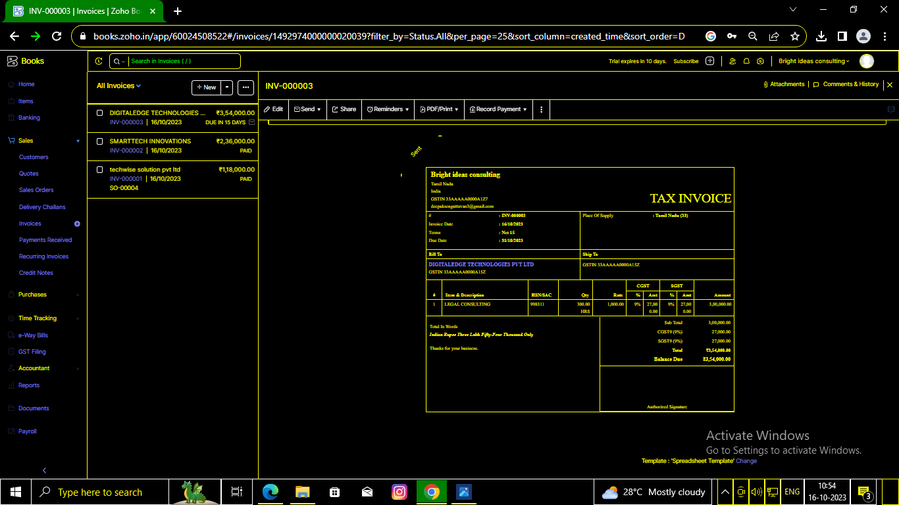

Bills:

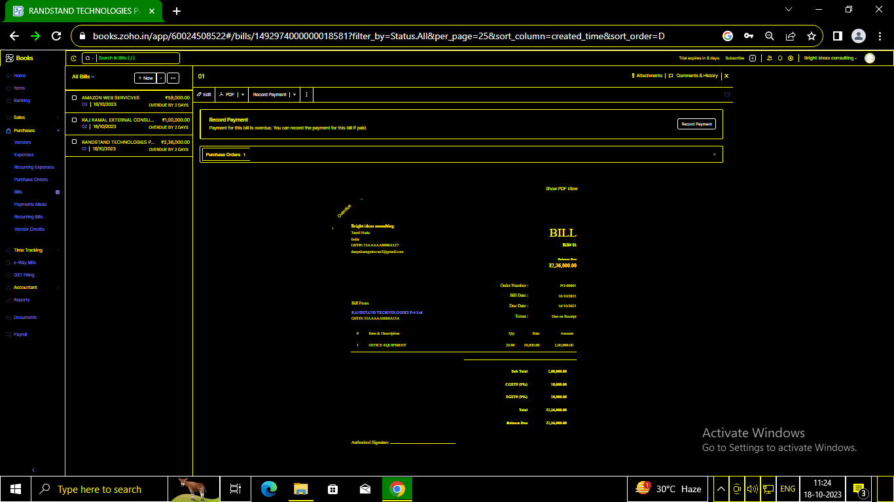

ADVANTAGES OF BRIGHT IDEAS CONSULTING :

Bright Ideas Medical Consulting can augment the work you and your team are already doing and offer strategic plans along with implementation steps. No practice is too small or too large for us. Our services are customized, affordable, and designed to meet unique need

DISADVANTAGES OF BRIGHT IDEAS CONSULTING:

The learning curve for mastering this product is quite high, and back end users will need to go through some extensive training with the Brightidea representatives.

1. *APPLICATIONS:*

*BRIGHT IDEAS CONSULTING*

1. **Conclusion:**

One of my passions is learning new teaching approaches or rediscovering ideas that have the potential to improve teacher practice and increase student

1. **FUTURE SCOPE:**

**Bright Ideas Consulting**  We are a Team of Experienced Professionals with more than 25 years in the Business of Commerce. We stress in successfully implementing

1. **APPENDIX:**

[**https://github.com/srinivasandeepak/bright-ideas-consulting_NM2023TMID23254**](https://github.com/srinivasandeepak/bright-ideas-consulting_NM2023TMID23254)

|  |
| --- |
|  |
| <!DOCTYPE html> |
|  | | | <html lang="en" data-color-mode="auto" data-light-theme="light" data-dark-theme="dark" data-a11y-animated-images="system" data-a11y-link-underlines="true"> |
|  | | |  |
|  | | | <style> |
|  | | | /* for each iteration, uncomment the CSS variable */ |
|  | | |  |
|  | | | /* light themes */ |
|  | | | [data-color-mode="light"][data-light-theme*="light"], |
|  | | | [data-color-mode="auto"][data-light-theme*="light"] { |
|  | | | /* iteration 1 */ |
|  | | | --border-color-iteration-1: #C8CCD0; |
|  | | | /* iteration 2 */ |
|  | | | --border-color-iteration-2: #BABFC5; |
|  | | | /* iteration 3 */ |
|  | | | --border-color-iteration-3: #A6ADB4; |
|  | | | /* iteration final */ |
|  | | | --border-color-iteration-4: #868F99; |
|  | | |  |
|  | | | /* the first value is the final step, which falls back to previous iterations */ |
|  | | | --control-borderColor-rest: var(--border-color-iteration-4, var(--border-color-iteration-3, var(--border-color-iteration-2, var(--border-color-iteration-1)))) !important; |
|  | | | } |
|  | | |  |
|  | | | /* dark themes */ |
|  | | | [data-color-mode="dark"][data-dark-theme*="dark"], |
|  | | | [data-color-mode="auto"][data-light-theme*="dark"] { |
|  | | | /* iteration 1 */ |
|  | | | --border-color-iteration-1: #363940; |
|  | | | /* iteration 2 */ |
|  | | | --border-color-iteration-2: #3F434B; |
|  | | | /* iteration 3 */ |
|  | | | --border-color-iteration-3: #4B5159; |
|  | | | /* iteration final */ |
|  | | | --border-color-iteration-4: #666E79; |
|  | | |  |
|  | | | /* the first value is the final step, which falls back to previous iterations */ |
|  | | | --control-borderColor-rest: var(--border-color-iteration-4, var(--border-color-iteration-3, var(--border-color-iteration-2, var(--border-color-iteration-1)))) !important; |
|  | | | } |
|  | | |  |
|  | | | [data-color-mode="dark"][data-dark-theme="dark_dimmed"], |
|  | | | [data-color-mode="dark"][data-dark-theme="light_high_contrast"], |
|  | | | [data-color-mode="dark"][data-dark-theme="dark_high_contrast"], |
|  | | | [data-color-mode="light"][data-light-theme="dark_dimmed"], |
|  | | | [data-color-mode="light"][data-light-theme="light_high_contrast"], |
|  | | | [data-color-mode="light"][data-light-theme="dark_high_contrast"] { |
|  | | | /* skip these themes, use the fallback */ |
|  | | | --control-borderColor-rest: initial !important; |
|  | | | } |
|  | | |  |
|  | | | @media (prefers-color-scheme: dark) { |
|  | | | /* dark colors in dark mode */ |
|  | | | [data-color-mode="auto"][data-dark-theme*="dark"] { |
|  | | | /* iteration 1 */ |
|  | | | --border-color-iteration-1: #363940; |
|  | | | /* iteration 2 */ |
|  | | | --border-color-iteration-2: #3F434B; |
|  | | | /* iteration 3 */ |
|  | | | --border-color-iteration-3: #4B5159; |
|  | | | /* iteration final */ |
|  | | | --border-color-iteration-4: #666E79; |
|  | | |  |
|  | | | /* the first value is the final step, which falls back to previous iterations */ |
|  | | | --control-borderColor-rest: var(--border-color-iteration-4, var(--border-color-iteration-3, var(--border-color-iteration-2, var(--border-color-iteration-1)))) !important; |
|  | | | } |
|  | | |  |
|  | | | /* light colors in dark mode */ |
|  | | | [data-color-mode="auto"][data-dark-theme*="light"] { |
|  | | | /* iteration 1 */ |
|  | | | --border-color-iteration-1: #C8CCD0; |
|  | | | /* iteration 2 */ |
|  | | | --border-color-iteration-2: #BABFC5; |
|  | | | /* iteration 3 */ |
|  | | | --border-color-iteration-3: #A6ADB4; |
|  | | | /* iteration final */ |
|  | | | --border-color-iteration-4: #868F99; |
|  | | |  |
|  | | | /* the first value is the final step, which falls back to previous iterations */ |
|  | | | --control-borderColor-rest: var(--border-color-iteration-4, var(--border-color-iteration-3, var(--border-color-iteration-2, var(--border-color-iteration-1)))) !important; |
|  | | | } |
|  | | |  |
|  | | | [data-color-mode="auto"][data-dark-theme="dark_dimmed"], |
|  | | | [data-color-mode="auto"][data-dark-theme="light_high_contrast"], |
|  | | | [data-color-mode="auto"][data-dark-theme="dark_high_contrast"] { |
|  | | | /* skip these themes, use the fallback */ |
|  | | | --control-borderColor-rest: initial !important; |
|  | | | } |
|  | | | } |
|  | | |  |
|  | | | @media (prefers-color-scheme: light) { |
|  | | | /* dark colors in light mode */ |
|  | | | [data-color-mode="auto"][data-light-theme*="dark"] { |
|  | | | /* iteration 1 */ |
|  | | | --border-color-iteration-1: #363940; |
|  | | | /* iteration 2 */ |
|  | | | --border-color-iteration-2: #3F434B; |
|  | | | /* iteration 3 */ |
|  | | | --border-color-iteration-3: #4B5159; |
|  | | | /* iteration final */ |
|  | | | --border-color-iteration-4: #666E79; |
|  | | |  |
|  | | | /* the first value is the final step, which falls back to previous iterations */ |
|  | | | --control-borderColor-rest: var(--border-color-iteration-4, var(--border-color-iteration-3, var(--border-color-iteration-2, var(--border-color-iteration-1)))) !important; |
|  | | | } |
|  | | |  |
|  | | | /* light colors in light mode */ |
|  | | | [data-color-mode="auto"][data-light-theme*="light"] { |
|  | | | /* iteration 1 */ |
|  | | | --border-color-iteration-1: #C8CCD0; |
|  | | | /* iteration 2 */ |
|  | | | --border-color-iteration-2: #BABFC5; |
|  | | | /* iteration 3 */ |
|  | | | --border-color-iteration-3: #A6ADB4; |
|  | | | /* iteration final */ |
|  | | | --border-color-iteration-4: #868F99; |
|  | | |  |
|  | | | /* the first value is the final step, which falls back to previous iterations */ |
|  | | | --control-borderColor-rest: var(--border-color-iteration-4, var(--border-color-iteration-3, var(--border-color-iteration-2, var(--border-color-iteration-1)))) !important; |
|  | | | } |
|  | | |  |
|  | | | [data-color-mode="auto"][data-light-theme="dark_dimmed"], |
|  | | | [data-color-mode="auto"][data-light-theme="light_high_contrast"], |
|  | | | [data-color-mode="auto"][data-light-theme="dark_high_contrast"] { |
|  | | | /* skip these themes, use the fallback */ |
|  | | | --control-borderColor-rest: initial !important; |
|  | | | } |
|  | | | } |
|  | | | </style> |
|  | | |  |
|  |
|  |  |
|  |  |
|  |  |
|  |  |
|  |  |
|  |  |
|  |  |
|  |  |
|  |  |
|  |  |
|  |  |
|  |  |
|  |  |
|  |  |
|  |  |
|  |  |
|  |  |
|  |  |
|  |  |
|  |  |
|  |  |
|  |  |
|  |  |
|  |  |
|  |  |
|  |  |
|  |  |
|  |  |
|  |  |
|  |  |
|  |  |
|  |  |
|  |  |
|  |  |
|  |  |
|  |  |
|  |  |
|  |  |
|  |  |
|  |  |
|  |  |
|  |  |
|  |  |
|  |  |
|  |  |
|  |  |
|  |  |
|  |  |
|  |  |
|  |  |
|  |  |
|  |  |
|  |  |
|  |  |
|  |  |
|  |  |
|  |  |
|  |  |
|  |  |
|  |  |
|  |  |
|  |  |
|  |  |
|  |  |
|  |  |
|  |  |
|  |  |
|  |  |
|  |  |
|  |  |
|  |  |
|  |  |
|  |  |
|  |  |
|  |  |
|  |  |
|  |  |
|  |  |
|  |  |
|  |  |
|  |  |
|  |  |
|  |  |
|  |  |
|  |  |
|  |  |
|  |  |
|  |  |
|  |  |
|  |  |
|  |  |
|  |  |
|  |  |
|  |  |
|  |  |
|  |  |
|  |  |
|  |  |
|  |  |
|  |  |
|  |  |
|  |  |
|  |  |
|  |  |
|  |  |
|  |  |
|  |  |
|  |  |
|  |  |
|  |  |
|  |  |
|  |  |
|  |  |
|  |  |
|  |  |
|  |  |
|  |  |
|  |  |
|  |  |
|  |  |
|  |  |
|  |  |
|  |  |
|  |  |
|  |  |

rel=”stylesheet” href=”./NM2023TMID22539_profit_and_loss.pdf at main · asmku643mku643c1c31260_NM2023TMID22539 · GitHub_files/light-b92e9647318f.css”><link crossorigin=”anonymous” media=”all” rel=”stylesheet” href=”./NM2023TMID22539_profit_and_loss.pdf at main · asmku643mku643c1c31260_NM2023TMID22539 · GitHub_files/dark-5d486a4ede8e.css”><link data-color-theme=”dark_dimmed” crossorigin=”anonymous” media=”all” rel=”stylesheet” data-href=https://github.githubassets.com/assets/dark_dimmed-27c8d635e4e5.css><link data-color-theme=”dark_high_contrast” crossorigin=”anonymous” media=”all”

rel=”stylesheet”

data-href=https://github.githubassets.com/assets/dark_high_contrast-8438e75afd36.css><lin k data-color-theme=”dark_colorblind” crossorigin=”anonymous” media=”all” rel=”stylesheet” data-href=https://github.githubassets.com/assets/dark_colorblind-bf5665b96628.css><link data-color-theme=”light_colorblind” crossorigin=”anonymous” media=”all” rel=”stylesheet” data-href=https://github.githubassets.com/assets/light_colorblind-c414b5ba1dce.css><link data-color-theme=”light_high_contrast” crossorigin=”anonymous” media=”all” rel=”stylesheet”

data-href=https://github.githubassets.com/assets/light_high_contrast-e5868b7374db.css><lin k data-color-theme=”light_tritanopia” crossorigin=”anonymous” media=”all” rel=”stylesheet” data-href=https://github.githubassets.com/assets/light_tritanopia-299ac9c64ec0.css><link data-color-theme=”dark_tritanopia” crossorigin=”anonymous” media=”all” rel=”stylesheet” data-href=h[ttps://github.githubassets.com/assets/dark_tritanopia-3a26e78ad0ff.css>](https://github.githubassets.com/assets/light_high_contrast-e5868b7374db.css)

<link cros[sorigin=”anonymous” media=”all” rel=”stylesheet”](https://github.githubassets.com/assets/dark_tritanopia-3a26e78ad0ff.css) href=”./NM2023TMID22539_profit_and_loss.pdf at main · asmku643mku643c1c31260_NM2023TMID22539 · GitHub_files/primer-primitives-6143c8f97ed1.css”>

<link crossorigin=”anonymous” media=”all” rel=”stylesheet” href=”./NM2023TMID22539_profit_and_loss.pdf at main · asmku643mku643c1c31260_NM2023TMID22539 · GitHub_files/primer-d6dcdf72e61d.css”>

<link crossorigin=”anonymous” media=”all” rel=”stylesheet” href=”./NM2023TMID22539_profit_and_loss.pdf at main · asmku643mku643c1c31260_NM2023TMID22539 · GitHub_files/global-ab1c3e3e5644.css”>

<link crossorigin=”anonymous” media=”all” rel=”stylesheet” href=”./NM2023TMID22539_profit_and_loss.pdf at main · asmku643mku643c1c31260_NM2023TMID22539 · GitHub_files/github-757ef6ea9a38.css”>

<link crossorigin=”anonymous” media=”all” rel=”stylesheet” href=”./NM2023TMID22539_profit_and_loss.pdf at main · asmku643mku643c1c31260_NM2023TMID22539 · GitHub_files/code-71ecd5638fbf.css”>

<script type=”application/json”

id=”client-env”>{“locale”:”en”,”featureFlags”:[“failbot_handle_non_errors”,”geojson_azure_m aps”,”image_metric_tracking”,”turbo_experiment_risky”,”sample_network_conn_type”]}</scri pt>

<script crossorigin=”anonymous” defer=”defer” type=”application/javascript” src=”./NM2023TMID22539_profit_and_loss.pdf at main · asmku643mku643c1c31260_NM2023TMID22539 ·

GitHub_files/wp-runtime-86f14561f3b0.js.download”></script>

<script crossorigin=”anonymous” defer=”defer” type=”application/javascript” src=”./NM2023TMID22539_profit_and_loss.pdf at main · asmku643mku643c1c31260_NM2023TMID22539 ·

GitHub_files/vendors-node_modules_dompurify_dist_purify_js-64d590970fa6.js.download”>

</script>

<script crossorigin=”anonymous” defer=”defer” type=”application/javascript” src=”./NM2023TMID22539_profit_and_loss.pdf at main · asmku643mku643c1c31260_NM2023TMID22539 ·

GitHub_files/vendors-node_modules_stacktrace-parser_dist_stack-trace-parser_esm_js-node_ modules_github_bro-a4c183-18bf85b8e9f4.js.download”></script>

<script crossorigin=”anonymous” defer=”defer” type=”application/javascript” src=”./NM2023TMID22539_profit_and_loss.pdf at main · asmku643mku643c1c31260_NM2023TMID22539 ·

GitHub_files/ui_packages_soft-nav_soft-nav_ts-56133143b228.js.download”></script>

<script crossorigin=”anonymous” defer=”defer” type=”application/javascript” src=”./NM2023TMID22539_profit_and_loss.pdf at main · asmku643mku643c1c31260_NM2023TMID22539 ·

GitHub_files/environment-fc6543d75794.js.download”></script>

<script crossorigin=”anonymous” defer=”defer” type=”application/javascript” src=”./NM2023TMID22539_profit_and_loss.pdf at main · asmku643mku643c1c31260_NM2023TMID22539 ·

GitHub_files/vendors-node_modules_github_selector-observer_dist_index_esm_js-2646a2c53 3e3.js.download”></script>

<script crossorigin=”anonymous” defer=”defer” type=”application/javascript” src=”./NM2023TMID22539_profit_and_loss.pdf at main · asmku643mku643c1c31260_NM2023TMID22539 ·

GitHub_files/vendors-node_modules_primer_behaviors_dist_esm_focus-zone_js-d55308df50 23.js.download”></script>

<script crossorigin=”anonymous” defer=”defer” type=”application/javascript” src=”./NM2023TMID22539_profit_and_loss.pdf at main · asmku643mku643c1c31260_NM2023TMID22539 ·

GitHub_files/vendors-node_modules_github_relative-time-element_dist_index_js-99e288659 d4f.js.download”></script>

<script crossorigin=”anonymous” defer=”defer” type=”application/javascript” src=”./NM2023TMID22539_profit_and_loss.pdf at main · asmku643mku643c1c31260_NM2023TMID22539 ·

GitHub_files/vendors-node_modules_fzy_js_index_js-node_modules_github_combobox-nav_ dist_index_js-node_modu-344bff-91b70bb50d68.js.download”></script>

<script crossorigin=”anonymous” defer=”defer” type=”application/javascript” src=”./NM2023TMID22539_profit_and_loss.pdf at main · asmku643mku643c1c31260_NM2023TMID22539 ·

GitHub_files/vendors-node_modules_delegated-events_dist_index_js-node_modules_github_ auto-complete-element-81d69b-f766607dc0c8.js.download”></script>

<script crossorigin=”anonymous” defer=”defer” type=”application/javascript” src=”./NM2023TMID22539_profit_and_loss.pdf at main · asmku643mku643c1c31260_NM2023TMID22539 ·

GitHub_files/vendors-node_modules_github_filter-input-element_dist_index_js-node_module s_github_remote-inp-2e8678-d593bf262480.js.download”></script>

<script crossorigin=”anonymous” defer=”defer” type=”application/javascript” src=”./NM2023TMID22539_profit_and_loss.pdf at main · asmku643mku643c1c31260_NM2023TMID22539 ·

GitHub_files/vendors-node_modules_github_file-attachment-element_dist_index_js-node_m odules_primer_view-co-70ad06-9f8bb7e4a8fa.js.download”></script>

<script crossorigin=”anonymous” defer=”defer” type=”application/javascript” src=”./NM2023TMID22539_profit_and_loss.pdf at main · asmku643mku643c1c31260_NM2023TMID22539 ·

GitHub_files/github-elements-30961cfd137b.js.download”></script>

<script crossorigin=”anonymous” defer=”defer” type=”application/javascript” src=”./NM2023TMID22539_profit_and_loss.pdf at main · asmku643mku643c1c31260_NM2023TMID22539 ·

GitHub_files/element-registry-e5f51987a7c5.js.download”></script>

<script crossorigin=”anonymous” defer=”defer” type=”application/javascript” src=”./NM2023TMID22539_profit_and_loss.pdf at main · asmku643mku643c1c31260_NM2023TMID22539 ·

GitHub_files/vendors-node_modules_lit-html_lit-html_js-4ccebb6ebf7d.js.download”></script

>

<script crossorigin=”anonymous” defer=”defer” type=”application/javascript” src=”./NM2023TMID22539_profit_and_loss.pdf at main · asmku643mku643c1c31260_NM2023TMID22539 ·

GitHub_files/vendors-node_modules_github_mini-throttle_dist_index_js-node_modules_gith ub_alive-client_dist-bf5aa2-504c8d53fb8e.js.download”></script>

<script crossorigin=”anonymous” defer=”defer” type=”application/javascript” src=”./NM2023TMID22539_profit_and_loss.pdf at main · asmku643mku643c1c31260_NM2023TMID22539 ·

GitHub_files/vendors-node_modules_morphdom_dist_morphdom-esm_js-b1fdd7158cf0.js.do wnload”></script>

<script crossorigin=”anonymous” defer=”defer” type=”application/javascript” src=”./NM2023TMID22539_profit_and_loss.pdf at main · asmku643mku643c1c31260_NM2023TMID22539 ·

GitHub_files/vendors-node_modules_github_turbo_dist_turbo_es2017-esm_js-9a3541181451

.js.download”></script>

<script crossorigin=”anonymous” defer=”defer” type=”application/javascript” src=”./NM2023TMID22539_profit_and_loss.pdf at main · asmku643mku643c1c31260_NM2023TMID22539 ·

GitHub_files/vendors-node_modules_github_remote-form_dist_index_js-node_modules_scrol l-anchoring_dist_scro-52dc4b-e1e33bfc0b7e.js.download”></script>

<script crossorigin=”anonymous” defer=”defer” type=”application/javascript” src=”./NM2023TMID22539_profit_and_loss.pdf at main · asmku643mku643c1c31260_NM2023TMID22539 ·

GitHub_files/vendors-node_modules_color-convert_index_js-35b3ae68c408.js.download”></s cript>

<script crossorigin=”anonymous” defer=”defer” type=”application/javascript” src=”./NM2023TMID22539_profit_and_loss.pdf at main · asmku643mku643c1c31260_NM2023TMID22539 ·

GitHub_files/vendors-node_modules_primer_behaviors_dist_esm_dimensions_js-node_modu les_github_jtml_lib_index_js-a18147cea3a6.js.download”></script>

<script crossorigin=”anonymous” defer=”defer” type=”application/javascript” src=”./NM2023TMID22539_profit_and_loss.pdf at main ·

asmku643mku643c1c31260_NM2023TMID22539 ·

GitHub_files/vendors-node_modules_github_paste-markdown_dist_index_esm_js-node_mod ules_github_quote-select-581a1f-4a3074d34892.js.download”></script>

<script crossorigin=”anonymous” defer=”defer” type=”application/javascript” src=”./NM2023TMID22539_profit_and_loss.pdf at main · asmku643mku643c1c31260_NM2023TMID22539 · GitHub_files/app_assets_modules_github_details-dialog_ts-app_assets_modules_github_fetc h_ts-add1ab03ecb3.js.download”></script>

<script crossorigin=”anonymous” defer=”defer” type=”application/javascript” src=”./NM2023TMID22539_profit_and_loss.pdf at main · asmku643mku643c1c31260_NM2023TMID22539 · GitHub_files/app_assets_modules_github_updatable-content_ts-ui_packages_hydro-analytics

_hydro-analytics_ts-0a5a30c9b976.js.download”></script>

<script crossorigin=”anonymous” defer=”defer” type=”application/javascript” src=”./NM2023TMID22539_profit_and_loss.pdf at main · asmku643mku643c1c31260_NM2023TMID22539 · GitHub_files/app_assets_modules_github_onfocus_ts-app_assets_modules_github_sticky-scr oll-into-view_ts-c56a5dfc8975.js.download”></script>

<script crossorigin=”anonymous” defer=”defer” type=”application/javascript” src=”./NM2023TMID22539_profit_and_loss.pdf at main · asmku643mku643c1c31260_NM2023TMID22539 · GitHub_files/app_assets_modules_github_behaviors_task-list_ts-app_assets_modules_github

_sso_ts-ui_packages-7d50ad-9491f2be61ee.js.download”></script>

<script crossorigin=”anonymous” defer=”defer” type=”application/javascript” src=”./NM2023TMID22539_profit_and_loss.pdf at main · asmku643mku643c1c31260_NM2023TMID22539 · GitHub_files/app_assets_modules_github_behaviors_ajax-error_ts-app_assets_modules_gith ub_behaviors_include-2e2258-d77f85c54572.js.download”></script>

<script crossorigin=”anonymous” defer=”defer” type=”application/javascript” src=”./NM2023TMID22539_profit_and_loss.pdf at main · asmku643mku643c1c31260_NM2023TMID22539 · GitHub_files/app_assets_modules_github_behaviors_commenting_edit_ts-app_assets_modul es_github_behaviors_ht-83c235-f22ac6b94445.js.download”></script>

<script crossorigin=”anonymous” defer=”defer” type=”application/javascript” src=”./NM2023TMID22539_profit_and_loss.pdf at main · asmku643mku643c1c31260_NM2023TMID22539 ·

GitHub_files/behaviors-8e3546d05c82.js.download”></script>

<script crossorigin=”anonymous” defer=”defer” type=”application/javascript” src=”./NM2023TMID22539_profit_and_loss.pdf at main · asmku643mku643c1c31260_NM2023TMID22539 ·

GitHub_files/vendors-node_modules_delegated-events_dist_index_js-node_modules_github_ catalyst_lib_index_js-623425af41e1.js.download”></script>

<script crossorigin=”anonymous” defer=”defer” type=”application/javascript” src=”./NM2023TMID22539_profit_and_loss.pdf at main · asmku643mku643c1c31260_NM2023TMID22539 ·

GitHub_files/notifications-global-0104a8043aa4.js.download”></script>

<script crossorigin=”anonymous” defer=”defer” type=”application/javascript” src=”./NM2023TMID22539_profit_and_loss.pdf at main · asmku643mku643c1c31260_NM2023TMID22539 ·

GitHub_files/vendors-node_modules_optimizely_optimizely-sdk_dist_optimizely_browser_es

_min_js-node_modules-089adc-8794271c9a65.js.download”></script>

<script crossorigin=”anonymous” defer=”defer” type=”application/javascript” src=”./NM2023TMID22539_profit_and_loss.pdf at main · asmku643mku643c1c31260_NM2023TMID22539 ·

GitHub_files/optimizely-b8ae60018b11.js.download”></script>

<script crossorigin=”anonymous” defer=”defer” type=”application/javascript” src=”./NM2023TMID22539_profit_and_loss.pdf at main · asmku643mku643c1c31260_NM2023TMID22539 ·

GitHub_files/vendors-node_modules_virtualized-list_es_index_js-node_modules_github_tem plate-parts_lib_index_js-677582870bfd.js.download”></script>

<script crossorigin=”anonymous” defer=”defer” type=”application/javascript” src=”./NM2023TMID22539_profit_and_loss.pdf at main · asmku643mku643c1c31260_NM2023TMID22539 ·

GitHub_files/vendors-node_modules_github_remote-form_dist_index_js-node_modules_dele gated-events_dist_inde-c537341-13ba07af3b2c.js.download”></script>

<script crossorigin=”anonymous” defer=”defer” type=”application/javascript” src=”./NM2023TMID22539_profit_and_loss.pdf at main · asmku643mku643c1c31260_NM2023TMID22539 · GitHub_files/app_assets_modules_github_ref-selector_ts-cad36de2ca60.js.download”></scrip t>

<script crossorigin=”anonymous” defer=”defer” type=”application/javascript” src=”./NM2023TMID22539_profit_and_loss.pdf at main ·

asmku643mku643c1c31260_NM2023TMID22539 · GitHub_files/codespaces-d5d24842ceda.js.download”></script>

<script crossorigin=”anonymous” defer=”defer” type=”application/javascript” src=”./NM2023TMID22539_profit_and_loss.pdf at main · asmku643mku643c1c31260_NM2023TMID22539 ·

GitHub_files/vendors-node_modules_github_filter-input-element_dist_index_js-node_module s_github_mini-throt-08ab15-d50c69097a3e.js.download”></script>

<script crossorigin=”anonymous” defer=”defer” type=”application/javascript” src=”./NM2023TMID22539_profit_and_loss.pdf at main · asmku643mku643c1c31260_NM2023TMID22539 ·

GitHub_files/vendors-node_modules_github_file-attachment-element_dist_index_js-node_m odules_github_mini-th-55cf52-b2acd5425c7c.js.download”></script>

<script crossorigin=”anonymous” defer=”defer” type=”application/javascript” src=”./NM2023TMID22539_profit_and_loss.pdf at main · asmku643mku643c1c31260_NM2023TMID22539 ·

GitHub_files/repositories-b80504a04cf8.js.download”></script>

<script crossorigin=”anonymous” defer=”defer” type=”application/javascript” src=”./NM2023TMID22539_profit_and_loss.pdf at main · asmku643mku643c1c31260_NM2023TMID22539 ·

GitHub_files/vendors-node_modules_github_remote-form_dist_index_js-node_modules_dele gated-events_dist_inde-0e9dbe-6435366f0862.js.download”></script>

<script crossorigin=”anonymous” defer=”defer” type=”application/javascript” src=”./NM2023TMID22539_profit_and_loss.pdf at main · asmku643mku643c1c31260_NM2023TMID22539 ·

GitHub_files/topic-suggestions-2e55863e3751.js.download”></script>

<script crossorigin=”anonymous” defer=”defer” type=”application/javascript” src=”./NM2023TMID22539_profit_and_loss.pdf at main · asmku643mku643c1c31260_NM2023TMID22539 ·

GitHub_files/code-menu-6bd50a0647d6.js.download”></script>

<meta http-equiv=”x-pjax-version” content=”d98aab6b69dc43e4407b1369c7bbfcf76dfab2d839011937153201c9b943f42f” data-turbo-track=”reload”>

<meta http-equiv=”x-pjax-csp-version” content=”ee14a7165914197d62e19f664bfb961fcfdfc1ec31939a5c7b137fbab1751c87” data-turbo-track=”reload”>

<meta http-equiv=”x-pjax-css-version” content=”664233c3fea08fdf2ac6994c09da8d00c5e5f750fe523a7605f44e0aafe71afe” data-turbo-track=”reload”>

<meta http-equiv=”x-pjax-js-version” content=”dd74378fedb3de5476a9fb9b72cce29ed416c09618bddd59f59777f848393889” data-turbo-track=”reload”>

<style type=”text/css” id=”operaUserStyle”></style>

<script type=”application/javascript” src=”./NM2023TMID22539_profit_and_loss.pdf at main

· asmku643mku643c1c31260_NM2023TMID22539 · GitHub_files/react-lib-210c4b5934c3.js.download”></script><script

type=”application/javascript” src=”./NM2023TMID22539_profit_and_loss.pdf at main · asmku643mku643c1c31260_NM2023TMID22539 ·

GitHub_files/vendors-node_modules_primer_octicons-react_dist_index_esm_js-node_module s_primer_react_lib-es-3db9ab-5f4faa9f1811.js.download”></script><script type=”application/javascript” src=”./NM2023TMID22539_profit_and_loss.pdf at main · asmku643mku643c1c31260_NM2023TMID22539 ·

GitHub_files/vendors-node_modules_primer_react_lib-esm_Box_Box_js-96a44addc402.js.do wnload”></script><script type=”application/javascript” src=”./NM2023TMID22539_profit_and_loss.pdf at main · asmku643mku643c1c31260_NM2023TMID22539 ·

GitHub_files/vendors-node_modules_primer_react_lib-esm_Button_Button_js-node_modules

_primer_react_lib-esm_-f6da63-1976b80d3486.js.download”></script><script type=”application/javascript” src=”./NM2023TMID22539_profit_and_loss.pdf at main · asmku643mku643c1c31260_NM2023TMID22539 ·

GitHub_files/vendors-node_modules_primer_react_lib-esm_Truncate_Truncate_js-node_mod

ules_primer_react_lib—5d1957-92534314547a.js.download”></script><script type=”application/javascript” src=”./NM2023TMID22539_profit_and_loss.pdf at main · asmku643mku643c1c31260_NM2023TMID22539 ·

GitHub_files/vendors-node_modules_primer_react_lib-esm_Button_index_js-node_modules_ primer_react_lib-esm_O-279bf8-c9a61955d545.js.download”></script><script type=”application/javascript” src=”./NM2023TMID22539_profit_and_loss.pdf at main · asmku643mku643c1c31260_NM2023TMID22539 ·

GitHub_files/vendors-node_modules_primer_react_lib-esm_Text_Text_js-node_modules_pri mer_react_lib-esm_Text-85a14b-0f28951279b7.js.download”></script><script type=”application/javascript” src=”./NM2023TMID22539_profit_and_loss.pdf at main · asmku643mku643c1c31260_NM2023TMID22539 ·

GitHub_files/vendors-node_modules_primer_react_lib-esm_ActionList_index_js-535c8ee1ebe 8.js.download”></script><script type=”application/javascript” src=”./NM2023TMID22539_profit_and_loss.pdf at main · asmku643mku643c1c31260_NM2023TMID22539 ·

GitHub_files/vendors-node_modules_primer_react_lib-esm_ActionMenu_ActionMenu_js-2f0 8ef908241.js.download”></script><script type=”application/javascript” src=”./NM2023TMID22539_profit_and_loss.pdf at main · asmku643mku643c1c31260_NM2023TMID22539 · GitHub_files/vendors-